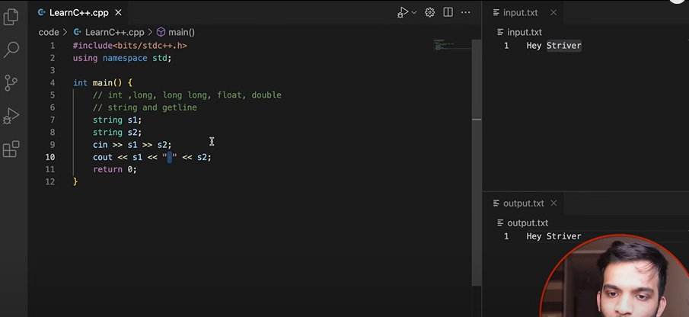Unique way of using some codes

Left side is executed but it checks every other subsequent if statement even if the prior statement is true. But, right stops after the condition is satisfied thus saving the time

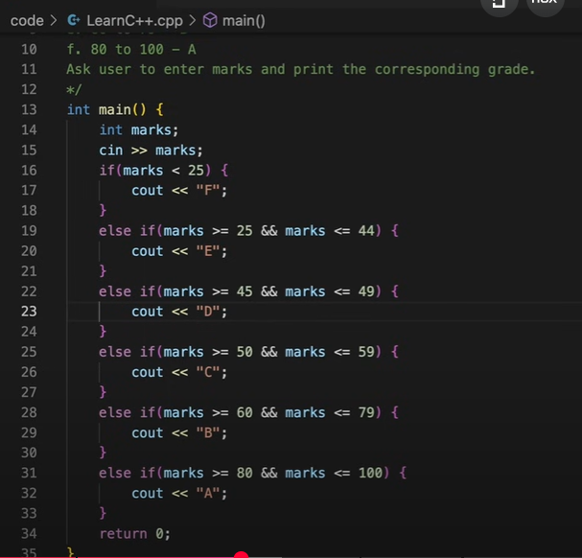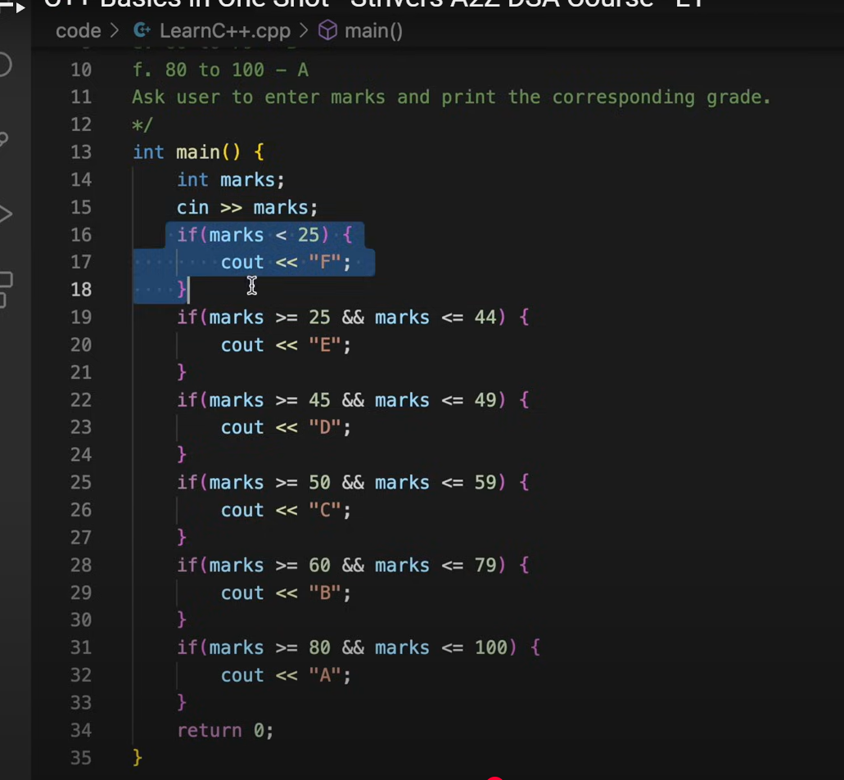

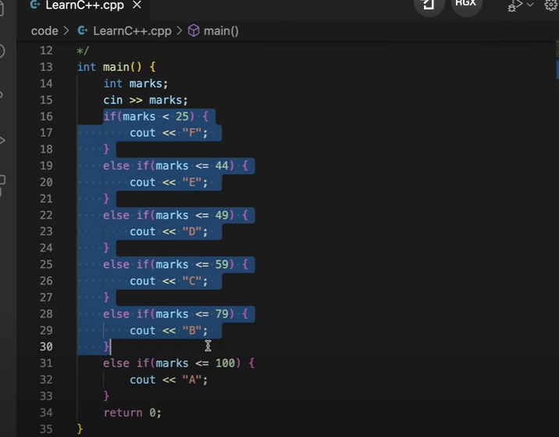

This is the same set of if-else statements as above, however it is more trimmed and optimized logically.

You can also see the below image for the reference in context to another question present at the left.  
Besides this, the image on the right shows nested if, but remember they don’t save time, they just control the flow of execution.

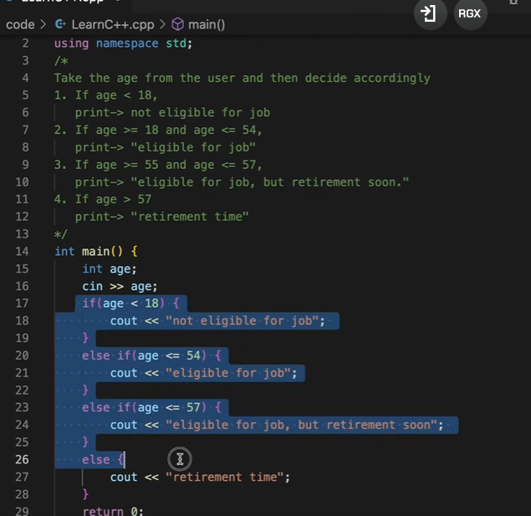

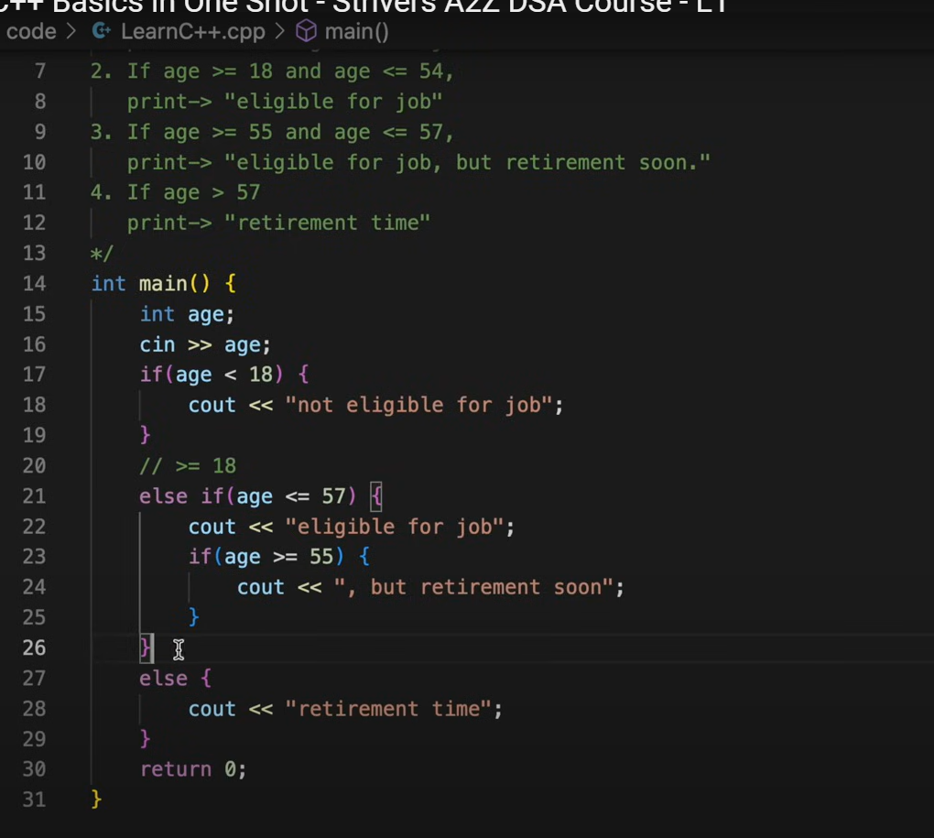

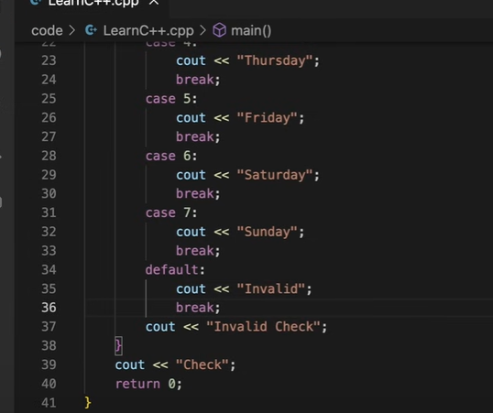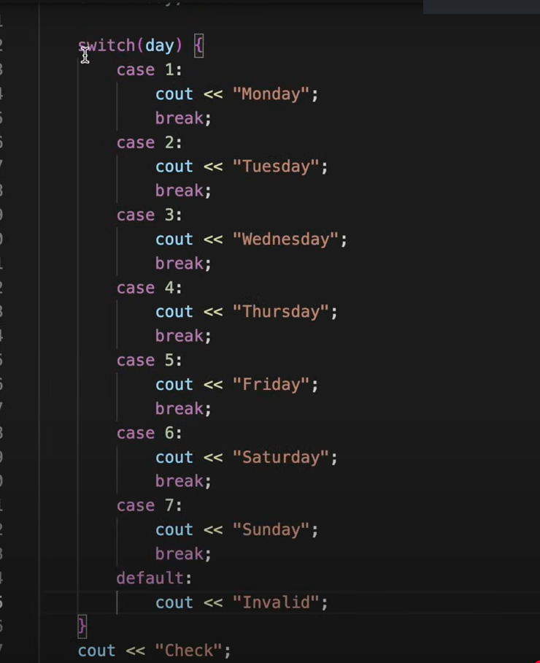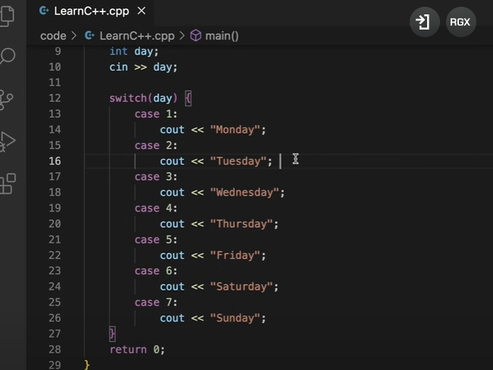Switch Case (break statement exits all the conditional statements)

Here, invalid check statement won’t be executed

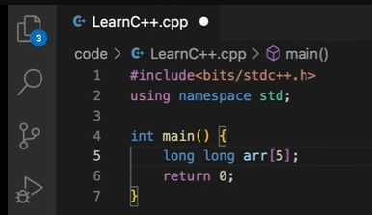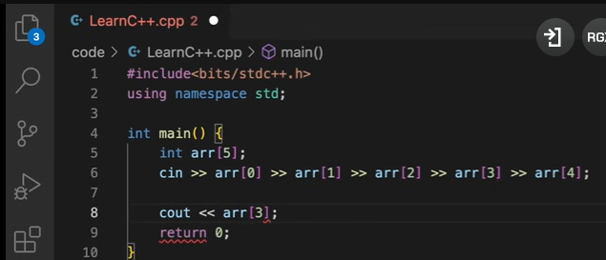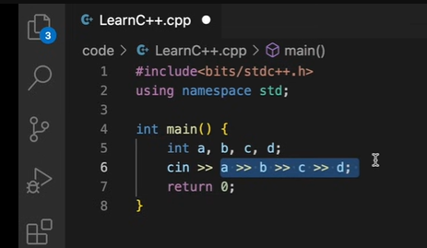Arrays

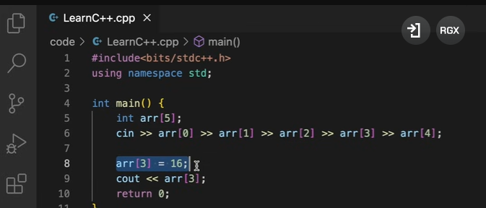

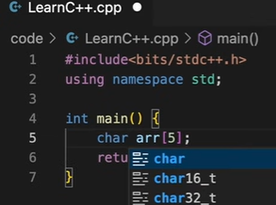

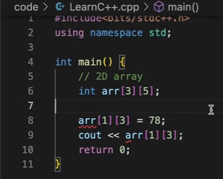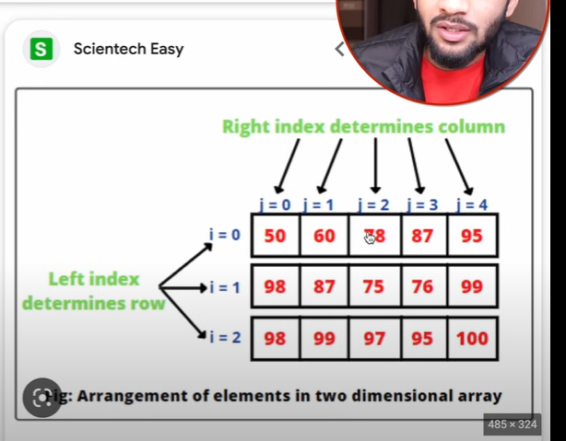2D Array

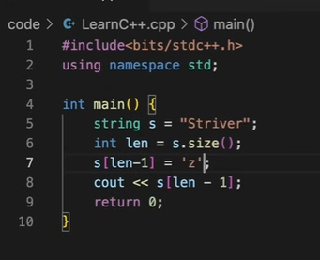

String (Array of characters)

Every index literally stores a character so you can’t use double quotes. Ex- we can’t write “z” as it would give error.

Besides this, [array].size() is a built-in function that returns the size/ length of the array.

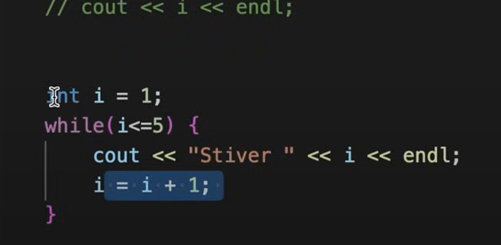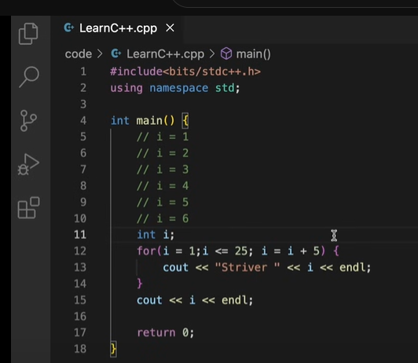For loops

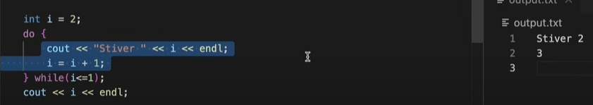

Do while loop executes the condition at least 1 time

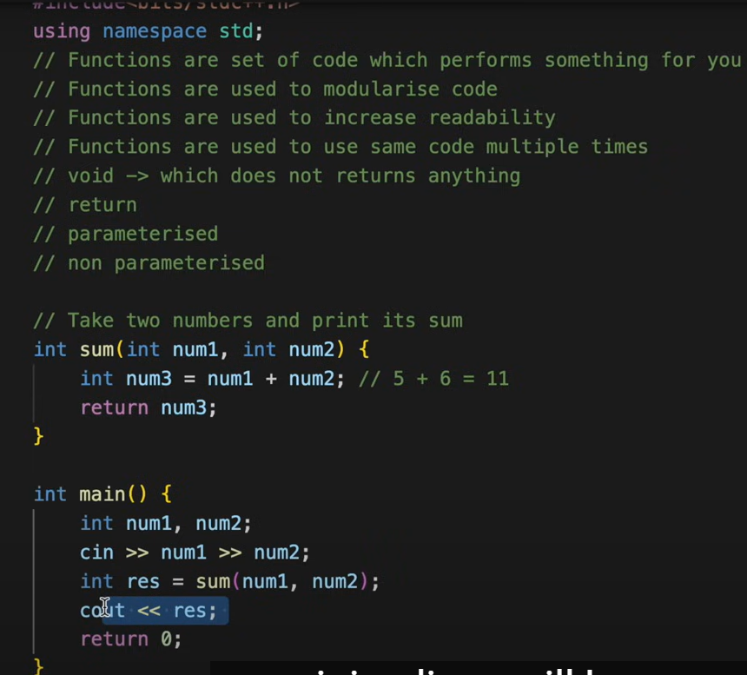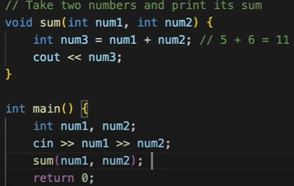Functions

In case of function calls the flow will go to the function. And the return Type of the function can be anything be it array, 2d array, vector, long long, char etc.

We also have some in-bulit functions like min and max as mentioned below.

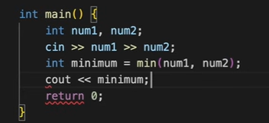

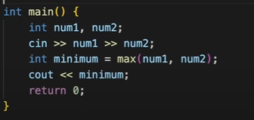

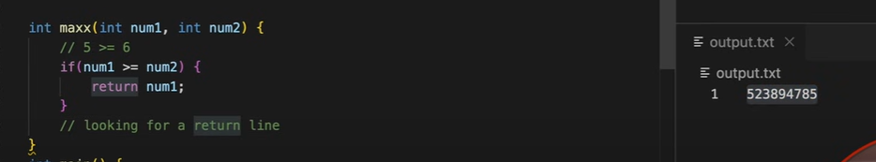

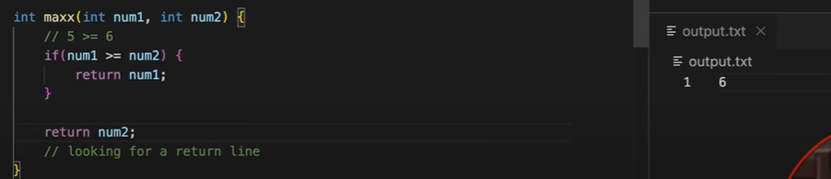



If a function has returnType then it must always have return otherwise it would give a garbage value like in this image

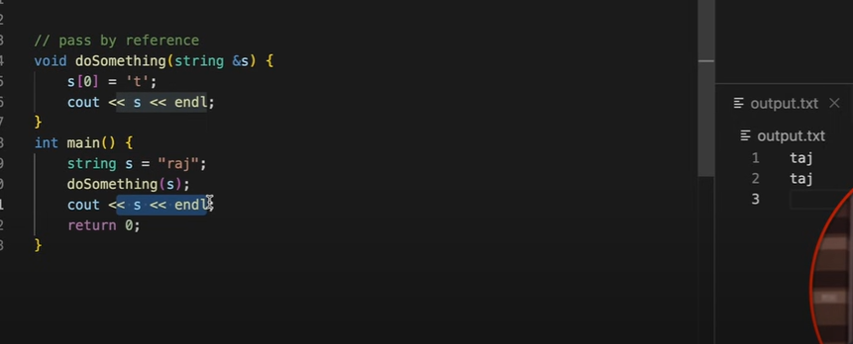

Pass by value, here a copy of the original value is supplied to the function and all the operations in the function is performed on that copied value.

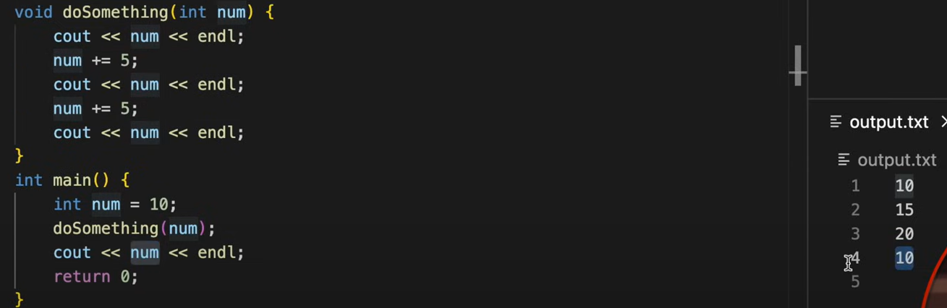

Pass by reference, here function works on the original value as it takes the address of that value through ‘&. This can also be return in a lot of other ways but this is the easiest one.  
  
Remember, that arrays are always passed by reference by default and they don’t require ‘&’ symbol for that.

However, apart from arrays other containers like vector, map, lists etc. You need to pass ‘&’ sign to PBR.

(Refer the image just below this dialog box. Values of array are inputted already.)

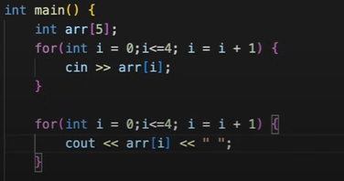

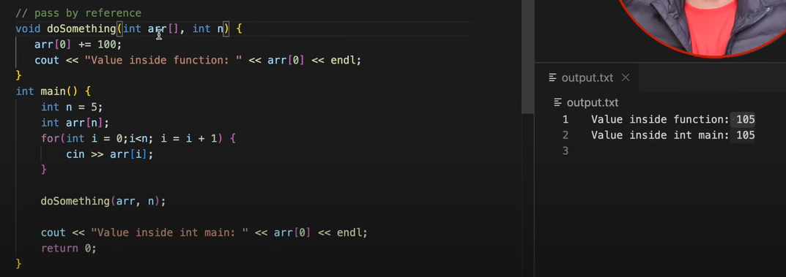

Local arrays created inside the function cannot be returned. But we can return vectors, and dynamic arrays directly.

Refer to the array question to know more

Combining array and loops

